Test Script
Date
OoliteStarter version
on operating system
Table of Contents
1 Installer 2
1.1 Install 2
1.2 Remove 2
1.3 Upgrade 2
1.4 Graphics 2
2 OoliteStarter 3
2.1 Installation Result 3
2.2 Oolite Versions Tab 3
2.2.1 Missing configuration 3
2.2.2 Empty configuration 3
2.2.3 Adding Oolite Version 4
2.2.4 Sorting 4
2.2.5 Autofill 4
2.2.6 Save reminder 4
2.3 OXPs/OXZs Tab 5
2.3.1 Sorting 5
2.3.2 Filtering 5
2.3.3 Validation 5
2.3.4 Export 5
2.3.5 Activation 5
2.3.6 Installation 5
2.3.7 Enabling 5
2.3.8 Disabling 5
2.3.9 Removal 5
2.4 Start Game Tab 5
2.4.1 Sorting 5
2.4.2 New 5
2.4.3 Resume 5
2.4.4 Expansions active at game play 5

Installer

Install
Ensure no version of OoliteStarter is installed. Download the latest release and install it.
If things did not go as expected, please describe.

Remove
After you installed the latest version, uninstall it.
If things did not go as expected, please describe.

Upgrade
Install some older version of OoliteStarter. Then install the latest version.
Did the upgrade detect the older version?
Were you asked to remove the old version?
If things did not go as expected, please describe.

Graphics
Mark the graphics that you saw on the screen during the install process.




Other? Please draw...

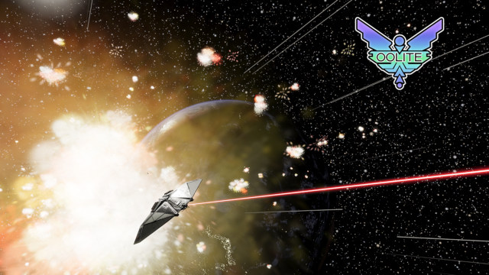

OoliteStarter

Installation Result
Do you have an Icon to start OoliteStarter?
If things did not go as expected, please describe.
Which icon did you use to bring up OoliteStarter?

Did you see the splash screen?

Oolite Versions Tab

Missing configuration
If OoliteStarter is already running, terminate it. Remove the configuration file $HOME/.oolite-starter.conf. Then start up OoliteStarter.
Did Mr. Gimlet warn you and offered default values?

Empty configuration
On the Oolite Versions tab, click the Save button. Terminate OoliteStarter and run it again.
Did Mr. Gimlet warn you and offer default values?
Were the default values useful?
If not, please elaborate.

Adding Oolite Version
Click the Add button. In the upcoming form, use the ellipsis button for the executable and browse the filesystem. Three types of folders should be marked up with an Oolite logo:
- folders containing an Oolite installation (oolite.app or Oolite.app)
- folders containing Oolite save games
- folders containing Oolite Expansions (OXP/OXZ)
Did these three folders get marked up? If not, describe the icon you saw and the content you found in that folder.

Sorting
When having several versions, can you sort them by clicking the table column headers?

Autofill
From the Oolite Version tab, click Add. In the upcoming form select the ellipsis button for the Home Directory. Select your oolite.app or Oolite.app folder.
Do the other values get populated automatically?
Are the guessed values correct?
If not, please elaborate.

Save reminder
After you modified the configuration (Add, Edit, Save), did OoliteStarter remind you to save the configuration?
After you saved the configuration, did the reminder go away?

OXPs/OXZs Tab

Sorting

Filtering

Validation

Export

Activation

Installation

Enabling

Disabling

Removal

Start Game Tab

Sorting

New

Resume

Expansions active at game play

